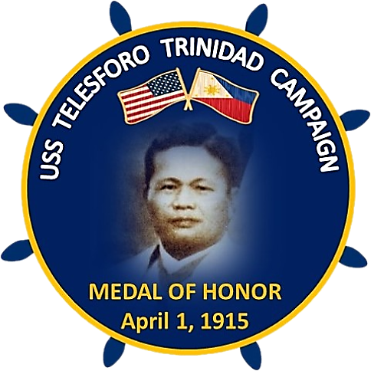

USS Telesforo Trinidad Campaign (USSTTC)
www.ussttc.org

FOR IMMEDIATE RELEASE CONTACT: Cecilia I. Gaerlan
May 20, 2022 (510) 520-8540; cecilia@bataanlegacy.org

SECNAV Names Future Arleigh Burke-Class Destroyer Telesforo Trinidad

May 20, 2022, Berkeley, CA – Secretary of the Navy (SECNAV) Carlos Del Toro made a monumental and historic announcement today naming the first U.S. warship after an enlisted American national of Filipino descent, Telesforo Trinidad. Fireman Second Class Trinidad holds the special distinction of being the first and only Asian American of Filipino descent in the U.S. Navy to receive a Medal of Honor on April 1, 1915, for his heroic act of saving two shipmates during two boiler explosions onboard the USS San Diego (ACR-6) in the California Coast on January 21, 1915.
“I am pleased to honor Trinidad’s life and legacy today – especially during Asian American Pacific Islander Heritage Month,” said Del Toro. “Having a ship named after such a significant figure highlights our diverse culture and that our people will always be our strategic advantage against any adversary. I hope the naming of this ship is a beacon for not only Asian Americans and Pacific Islanders but for all of our Sailors, Marines and Civilians who serve across the Department of the Navy.”
The USS Telesforo Trinidad Campaign (USSTTC) was founded during the fall of 2020 by COL Nonie C. Cabana, USAF-Ret, who currently serves as its Executive Director. It is chaired by CAPT Ronald Ravelo, USN (Ret), the first Filipino American to command a nuclear-powered aircraft carrier. USSTTC garnered massive support across the country led by veterans’ and civic organizations, local, state, and national legislators and grass roots support from many individuals.
Cabana commented “Filipinos and Filipino Americans have waited over 107 years to see this watershed moment happen. We realize that building grassroots and ground swelling support is the key to sustain momentum in convincing Honorable Secretary Del Toro to make this seminal decision as part of our Nation’s history.”

Ravelo commented, “naming a ship after Trinidad sends a strong message that America embraces diversity, equity and inclusion. The old and new generations of Americans of Filipino descent who served and continue to serve our military would keep their heads raised high knowing their contributions are embodied through the USS Telesforo Trinidad.”

For more information, please visit Navy.Mil/Press-Office or www.ussttc.org.

###

